**HOTEL MANAGEMENT SYSTEM DBMS PROJECT**

Burcu Acar

Bay Atlantic University

CMPS 520: Database Design Concepts

Gregory Liu

November 20, 2023

# INTRODUCTION

This project includes the database design of a hotel management system which has tables and their relationships, the columns and types of values and script of the database. Moreover, the users created for maintain security measures and roles to given them. Lastly, the Entity Relationship Diagram (ERD).

**Table Contents**

1. **Address**: This table contains address information of entire employees, guests and hotels.
2. **Department**: This table contains departmen information.
3. **Employee**: This table contains employee information of entire three hotels.
4. **EmployeeStatus**:This table contains the employee status of employees for use in the employee table.
5. **Expense**: This table contains the hotels’ expense information. It includes information about which employee added the expense data, date, amount, expense type, and expense status information showing whether payment has been paid or not.
6. **ExpenseStatus**: This table contains the payment status information of the expense to be used in the Expense table.
7. **ExpenseType**: This table contains information about the hotel's expense types to be used in the Expense table.
8. **Guest**: This table contains information such as name, surname and telephone number of hotel customers.
9. **Hotel**: This table contains information for all available hotels; such as hotel name, telephone number, address, room capacity, rating and hotel usage status.
10. **Item**: This table contains the name, price and condition information of all the items that the hotel generates income from or sells.
11. **ItemStatus**: This table contains the status information of each thing in the “Item” table like "Available" or "Out Of Stock"
12. **ItemType**: This table contains and categorizes the type of each item in the Item table.
13. **Payment** : This table is the transaction table. The total of all payments made by customers is recorded in the table as a row. It contains information such as payment type, amount, reservation number, payment date and payment status.
14. **PaymentDetail**: This table contains the detailed information of each payment, the total amount of which is shown in the payment table. It contains PaymentId, ItemId, ItemTypeId and amount information.
15. **PaymentStatus**: This table contains payment status information to be used in the Payment table.
16. **PaymentType**: This table contains information about the type of payment to be used in the Payment table.
17. **Reservation**: This table contains information about all reservations made to the hotel so far. It includes GuestId, RoomId, CheckInDate, CheckOutDate, the status of the reservation and information about which employee added the data.
18. **ReservationStatus**: This table contains reservation statu information.
19. **Room**: This table contains information on all hotel rooms available in total. It includes the hotel's room, room number, room status and room Id information.
20. **RoomStatus**: This table contains room status information as “Vacant” or “Booked”
21. **RoomType**: This table contains room types and their cost.

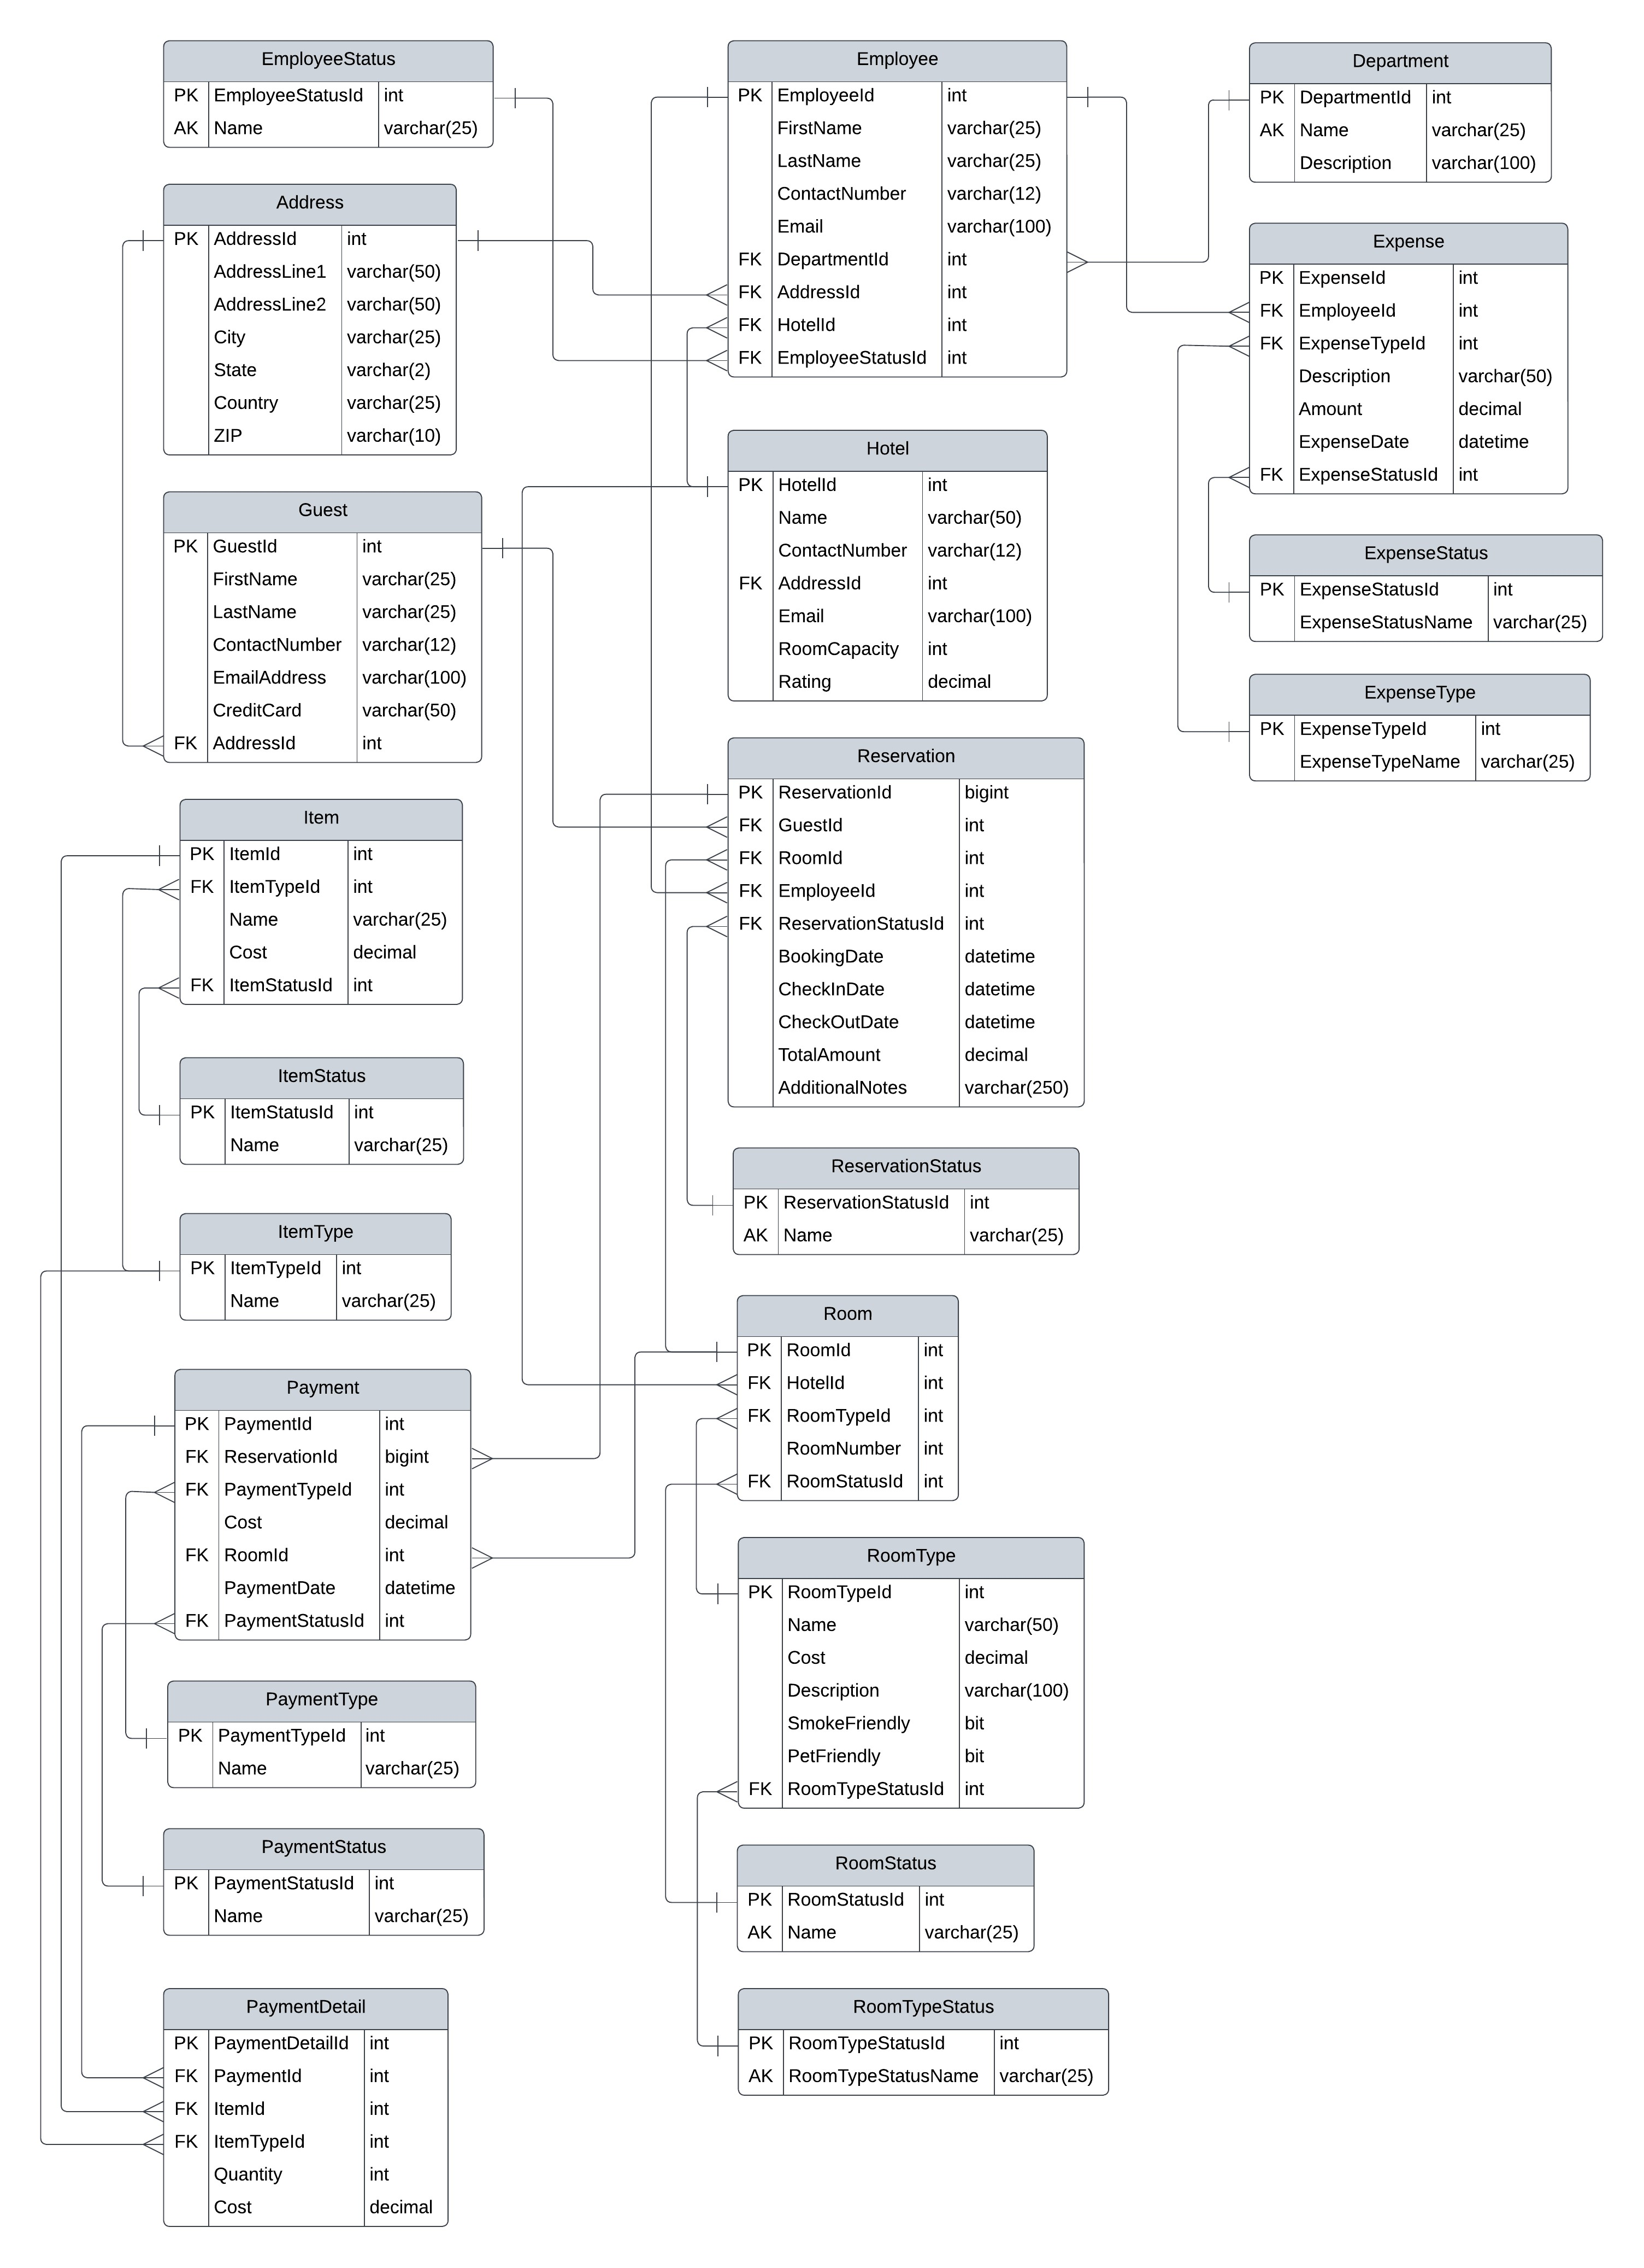

ENTITY RELATIONSHIP DIAGRAM (ERD)

**TABLE DETAILS**

|  |  |  |  |
| --- | --- | --- | --- |
| **Column Name** | **Data Type** | **Key** | **Required** |
| AddressId | int | Primary Key | Yes |
| AddressLine1 | varchar(50) | No | Yes |
| AddressLine2 | varchar(50) | No | No |
| City | varchar(25) | No | Yes |
| State | char(2) | No | No |
| Country | varchar(25) | No | Yes |
| ZIP | varchar(10) | No | No |
|  | **ADDRESS** |  |  |

|  |  |  |  |
| --- | --- | --- | --- |
| **Column Name** | **Data Type** | **Key** | **Required** |
| DepartmentId | int | Primary Key | Yes |
| Name | varchar(25) | No | Yes |
| Description | varchar(100) | No | No |
|  | **DEPARTMENT** | |  |

|  |  |  |  |
| --- | --- | --- | --- |
| **Column Name** | **Data Type** | **Key** | **Required** |
| EmployeeId | int | Primary Key | Yes |
| FirstName | varchar(25) | No | Yes |
| LastName | varchar(25) | No | Yes |
| ContactNumber | varchar(12) | No | Yes |
| Email | varchar(100) | No | Yes |
| DepartmentId | int | Foreign Key | Yes |
| AddressId | int | Foreign Key | Yes |
| HotelId | int | Foreign Key | Yes |
| EmployeeStatusId | int | Foreign Key | Yes |
|  | **EMPLOYEE** | |  |

|  |  |  |  |
| --- | --- | --- | --- |
| **Column Name** | **Data Type** | **Key** | **Required** |
| EmployeeStatusId | int | Primary Key | Yes |
| Name | varchar(25) | No | Yes |
|  | **EMPLOYEESTATUS** | |  |

|  |  |  |  |
| --- | --- | --- | --- |
| **Column Name** | **Data Type** | **Key** | **Required** |
| ExpenseId | int | Primary Key | Yes |
| EmployeeId | int | Foreign Key | Yes |
| ExpenseTypeId | int | Foreign Key | Yes |
| Description | varchar(50) | No | No |
| Amount | decimal(18,2) | No | Yes |
| ExpenseDate | datetime | No | Yes |
| ExpenseStatusId | int | Foreign Key | Yes |
|  | **EXPENSE** |  |  |

|  |  |  |  |
| --- | --- | --- | --- |
| **Column Name** | **Data Type** | **Key** | **Required** |
| ExpenseStatusId | int | Primary Key | Yes |
| Name | varchar(25) | No | Yes |
|  | **EXPENSESTATUS** | |  |

|  |  |  |  |
| --- | --- | --- | --- |
| **Column Name** | **Data Type** | **Key** | **Required** |
| ExpenseTypeId | int | Primary Key | Yes |
| Name | varchar(25) | No | Yes |
|  | **EXPENSETYPE** | |  |

|  |  |  |  |
| --- | --- | --- | --- |
| **Column Name** | **Data Type** | **Key** | **Required** |
| GuestId | int | Primary Key | Yes |
| FirstName | varchar(25) | No | Yes |
| LastName | varchar(25) | No | Yes |
| ContactNumber | varchar(12) | No | Yes |
| EmailAddress | varchar(100) | No | Yes |
| CreditCard | varchar(50) | No | Yes |
| AddressId | int | Foreign Key | Yes |
|  | **GUEST** |  |  |

|  |  |  |  |
| --- | --- | --- | --- |
| **Column Name** | **Data Type** | **Key** | **Required** |
| ItemStatusId | int | Primary Key | Yes |
| Name | varchar(25) | No | Yes |
|  | **ITEMSTATUS** | |  |

|  |  |  |  |
| --- | --- | --- | --- |
| **Column Name** | **Data Type** | **Key** | **Required** |
| ItemTypeId | int | Primary Key | Yes |
| Name | varchar(25) | No | Yes |
|  | **ITEMTYPE** |  |  |

|  |  |  |  |
| --- | --- | --- | --- |
| **Column Name** | **Data Type** | **Key** | **Required** |
| HotelId | int | PrimaryKey | Yes |
| Name | varchar(50) | No | Yes |
| ContactNumber | varchar(12) | No | Yes |
| AddressId | int | ForeignKey | Yes |
| Email | varchar(100) | No | Yes |
| RoomCapacity | int | No | Yes |
| Rating | decimal(3,2) | No | No |
|  | **HOTEL** |  |  |

|  |  |  |  |
| --- | --- | --- | --- |
| **Column Name** | **Data Type** | **Key** | **Required** |
| ItemId | int | PrimaryKey | Yes |
| ItemTypeId | int | ForeignKey | Yes |
| Name | varchar(25) | No | Yes |
| Cost | decimal(18,2) | No | Yes |
| ItemStatusId | int | ForeignKey | Yes |
|  | **ITEM** |  |  |

|  |  |  |  |
| --- | --- | --- | --- |
| **Column Name** | **Data Type** | **Key** | **Required** |
| PaymentId | int | PrimaryKey | Yes |
| ReservationId | bigint | ForeignKey | Yes |
| PaymentTypeId | int | ForeignKey | Yes |
| Cost | decimal(18,2) | No | Yes |
| RoomId | int | ForeignKey | Yes |
| PaymentDate | datetime | No | Yes |
| PaymentStatusId | int | ForeignKey | Yes |
|  | **PAYMENT** |  |  |

|  |  |  |  |
| --- | --- | --- | --- |
| **Column Name** | **Data Type** | **Key** | **Required** |
| PaymentStatusId | int | Primary Key | Yes |
| Name | varchar(25) | No | Yes |
|  | **PAYMENTSTATUS** | |  |

|  |  |  |  |
| --- | --- | --- | --- |
| **Column Name** | **Data Type** | **Key** | **Required** |
| PaymentDetailId | int | ForeignKey | Yes |
| PaymentId | int | ForeignKey | Yes |
| ItemId | int | ForeignKey | Yes |
| ItemTypeId | int | ForeignKey | Yes |
| Quantity | int | ForeignKey | Yes |
| Cost | decimal(18,2) | No | Yes |
|  | **PAYMENTDETAIL** | |  |

|  |  |  |  |
| --- | --- | --- | --- |
| **Column Name** | **Data Type** | **Key** | **Required** |
| PaymentTypeId | int | Primary Key | Yes |
| Name | varchar(25) | No | Yes |
|  | **PAYMENTTYPE** | |  |

|  |  |  |  |
| --- | --- | --- | --- |
| **Column Name** | **Data Type** | **Key** | **Required** |
| ReservationId | bigint | Primary Key | Yes |
| GuestId | int | ForeignKey | Yes |
| RoomId | int | ForeignKey | Yes |
| EmployeeId | int | ForeignKey | Yes |
| ReservationStatusId | int | ForeignKey | Yes |
| BookingDate | datetime | No | Yes |
| CheckInDate | datetime | No | No |
| CheckOutDate | datetime | No | No |
| TotalAmount | decimal(18,2) | No | Yes |
| AdditionalNotes | varchar(100) | No | No |
|  | **RESERVATION** | |  |

|  |  |  |  |  |  |  |
| --- | --- | --- | --- | --- | --- | --- |
| **Column Name** | | **Data Type** | | **Key** | **Required** | |
| ReservationStatusId | | int | | Primary Key | Yes | |
| Name | | varchar(25) | | No | Yes | |
|  | | **RESERVATIONSTATUS** | | |  | |
| **Column Name** | **Data Type** | | **Key** | | | **Required** | |
| RoomId | int | | PrimaryKey | | | Yes | |
| HotelId | int | | ForeignKey | | | Yes | |
| RoomTypeId | int | | ForeignKey | | | Yes | |
| RoomNumber | int | | No | | | Yes | |
| RoomStatusId | int | | ForeignKey | | | Yes | |

**ROOM**

|  |  |  |  |
| --- | --- | --- | --- |
| **Column Name** | **Data Type** | **Key** | **Required** |
| RoomStatusId | int | Primary Key | Yes |
| Name | varchar(25) | No | Yes |
|  | **ROOMSTATUS** | |  |

|  |  |  |  |
| --- | --- | --- | --- |
| **Column Name** | **Data Type** | **Key** | **Required** |
| RoomTypeId | int | PrimaryKey | Yes |
| Name | varchar(25) | No | Yes |
| Cost | decimal(18,2) | No | Yes |
| Description | varchar(100) | No | No |
| SmokeFriendly | bit | No | Yes |
| PetFriendly | bit | No | Yes |
| RoomTypeStatusId | int | No | No |
|  | **ROOMTYPE** | |  |

|  |  |  |  |
| --- | --- | --- | --- |
| **Column Name** | **Data Type** | **Key** | **Required** |
| RoomTypeStatusId | int | Primary Key | Yes |
| Name | varchar(25) | No | Yes |
|  | **ROOMTYPESTATUS** | |  |

|  |  |  |  |
| --- | --- | --- | --- |
| **DATABASE RIGHTS GRANTED** | |  |  |
| **Table** | **Administrative Assistants** | **Management** | **System Administrator** |
| Address | Read, Insert, Change | Read, Insert, Change,Delete | Grant Rights, Modify Structure |
| Department | Read, Insert, Change | Read, Insert, Change,Delete | Grant Rights, Modify Structure |
| Employee | Read, Insert, Change | Read, Insert, Change | Grant Rights, Modify Structure |
| EmployeeStatus | Read, Insert, Change | Read, Insert, Change,Delete | Grant Rights, Modify Structure |
| Expense | Read, Insert, Change | Read, Insert, Change | Grant Rights, Modify Structure |
| ExpenseStatus | Read, Insert, Change | Read, Insert, Change,Delete | Grant Rights, Modify Structure |
| ExpenseType | Read, Insert, Change | Read, Insert, Change,Delete | Grant Rights, Modify Structure |
| Guest | Read, Insert, Change | Read, Insert, Change | Grant Rights, Modify Structure |

|  |  |  |  |
| --- | --- | --- | --- |
| **DATABASE RIGHTS GRANTED** | |  |  |
| **Table** | **Administrative Assistants** | **Management** | **System Administrator** |
| Hotel | Read, Insert, Change | Read, Insert, Change | Grant Rights, Modify Structure |
| Item | Read, Insert, Change,Delete | Read, Insert, Change,Delete | Grant Rights, Modify Structure |
| ItemStatus | Read, Insert, Change | Read, Insert, Change,Delete | Grant Rights, Modify Structure |
| ItemType | Read, Insert, Change | Read, Insert, Change,Delete | Grant Rights, Modify Structure |
| Payment | Read, Insert, Change | Read, Insert, Change | Grant Rights, Modify Structure |
| PaymentDetail | Read, Insert, Change | Read, Insert, Change | Grant Rights, Modify Structure |
| PaymentStatus | Read, Insert, Change | Read, Insert, Change,Delete | Grant Rights, Modify Structure |
| PaymentType | Read, Insert, Change | Read, Insert, Change,Delete | Grant Rights, Modify Structure |
| Reservation | Read, Insert, Change | Read, Insert, Change | Grant Rights, Modify Structure |
| ReservationStatus | Read, Insert, Change | Read, Insert, Change,Delete | Grant Rights, Modify Structure |
| Room | Read, Insert, Change | Read, Insert, Change | Grant Rights, Modify Structure |
| RoomStatus | Read, Insert, Change | Read, Insert, Change,Delete | Grant Rights, Modify Structure |
| RoomType | Read, Insert, Change | Read, Insert, Change,Delete | Grant Rights, Modify Structure |
| RoomTypeStatus | Read, Insert, Change | Read, Insert, Change,Delete | Grant Rights, Modify Structure |

|  |  |  |  |  |
| --- | --- | --- | --- | --- |
| **Referential Integrity Constraint Enforcement for Hotel Management System Database** | | | | |
| **Relationship** | | **Referential Integrity Constraint** | **Cascading Behavior** | |
| **Parent** | **Child** |  | **Update Rule** | **Delete Rule** |
| DEPARTMENT | EMPLOYEE | DepartmentId in EMPLOYEE must exist in DepartmentId in DEPARTMENT | No Action | Set Null |
| ADDRESS | EMPLOYEE | AddressId in EMPLOYEE must exist in AddressId in ADDRESS | No Action | No Action |
| EMPLOYEESTATUS | EMPLOYEE | EmployeeStatusId in EMPLOYEE must exist in EmployeeStatusId in EMPLOYEESTATUS | No Action | No Action |
| HOTEL | EMPLOYEE | HotelId in EMPLOYEE must exist in HotelId in HOTEL | No Action | No Action |
| EMPLOYEE | EXPENSE | EmployeeId in EXPENSE must exist in EmployeeId in EMPLOYEE | No Action | No Action |
| EXPENSESTATUS | EXPENSE | ExpenseStatusId in EXPENSE must exist in ExpenseStatusIdId in EXPENSESTATUS | No Action | No Action |
| EXPENSETYPE | EXPENSE | ExpenseTypeId in EXPENSE must exist in ExpenseTypeId in EXPENSETYPE | No Action | No Action |
| ADDRESS | GUEST | AddressId in GUEST must exist in AddressId in ADDRESS | No Action | No Action |
| ADDRESS | HOTEL | AddressId in HOTEL must exist in AddressId in ADDRESS | No Action | No Action |

|  |  |  |  |  |
| --- | --- | --- | --- | --- |
| ITEMSTATUS | ITEM | ItemStatusId in ITEM must exist in ItemStatusId in ITEMSTATUS | No Action | No Action |
| ITEMTYPE | ITEM | ItemTypeId in ITEM must exist in AddressId in ITEMTYPE | No Action | No Action |
| PAYMENTSTATUS | PAYMENT | PaymentStatusId in PAYMENT must exist in PaymentStatusId in PAYMENTSTATUS | No Action | No Action |
| PAYMENTTYPE | PAYMENT | PaymentTypeId in PAYMENT must exist in PaymentTypeId in PAYMENTTYPE | No Action | No Action |
| RESERVATION | PAYMENT | ReservationId in PAYMENT must exist in ReservationId in RESERVATION | No Action | No Action |
| ROOM | PAYMENT | RoomId in PAYMENT must exist in RoomId in ROOM | No Action | No Action |
| ITEM | PAYMENTDETAIL | ItemId in PAYMENTDETAIL must exist in ItemId in ITEM | No Action | No Action |
| ITEMTYPE | PAYMENTDETAIL | ItemTypeId in PAYMENTDETAIL must exist in ItemTypeId in ITEMTYPE | No Action | No Action |
| PAYMENT | PAYMENTDETAIL | PaymentId in PAYMENTDETAIL must exist in PaymentId in PAYMENT | No Action | No Action |
| EMPLOYEE | RESERVATION | EmployeeId in RESERVATION must exist in EmployeeId in EMPLOYEE | No Action | No Action |

|  |  |  |  |  |
| --- | --- | --- | --- | --- |
| GUEST | RESERVATION | GuestId in RESERVATION must exist in GuestId in GUEST | No Action | No Action |
| RESERVATIONSTATUS | RESERVATION | ReservationStatusId in RESERVATION must exist in ReservationStatusId in RESERVATIONSTATUS | No Action | No Action |
| ROOM | RESERVATION | RoomId in RESERVATION must exist in RoomId in ROOM | No Action | No Action |
| HOTEL | ROOM | HotelId in ROOM must exist in HotelId in HOTEL | No Action | No Action |
| ROOMSTATUS | ROOM | RoomStatusId in ROOM must exist in RoomStatusId in ROOMSTATUS | No Action | No Action |
| ROOMTYPE | ROOM | RoomTypeId in ROOM must exist in RoomTypeId in ROOMTYPE | No Action | No Action |
| ROOMTYPESTATUS | ROOMTYPE | RoomTypeStatusId in ROOMTYPE must exist in RoomTypeStatusIdd in ROOMTYPESTATUS | No Action | No Action |

**DATABASE SECURITY MEASURES**

In order for the database to comply with security measures, I first created three new logins under the server, named "Management", "AdminAssistant" and "SystemAdministrator". Then, I created users with the same name as the logins for each login I created, to be used in the Hotel database. The following pages contain screenshots of the operations I performed.

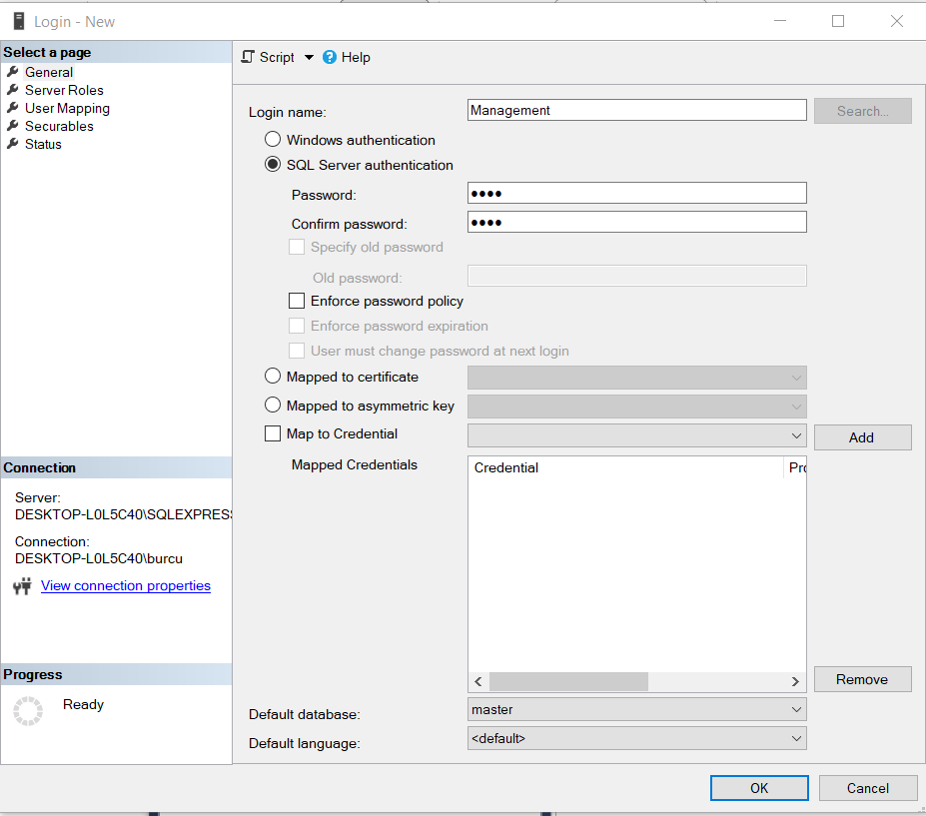

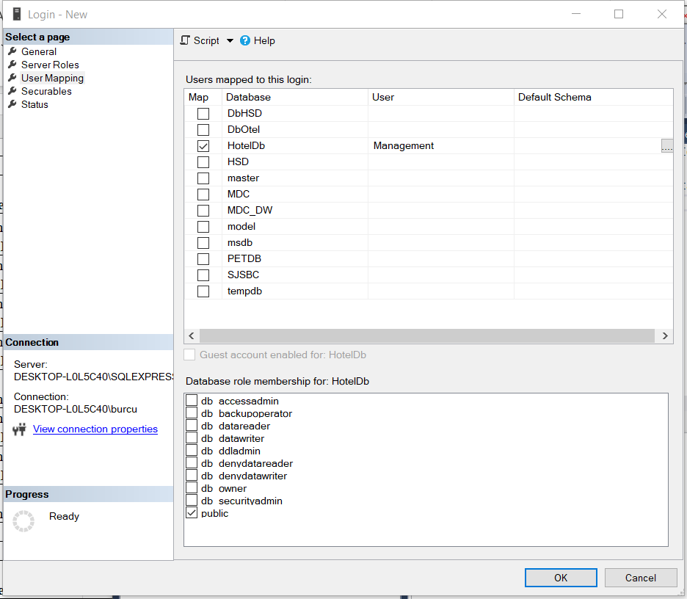

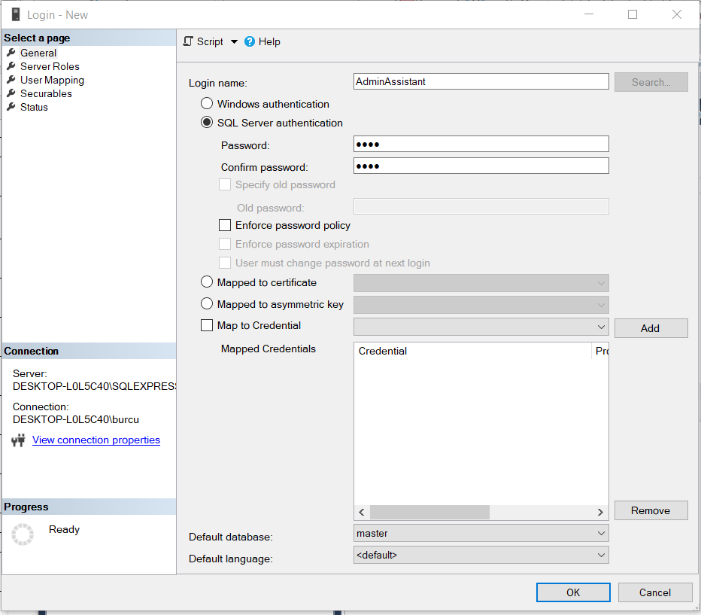

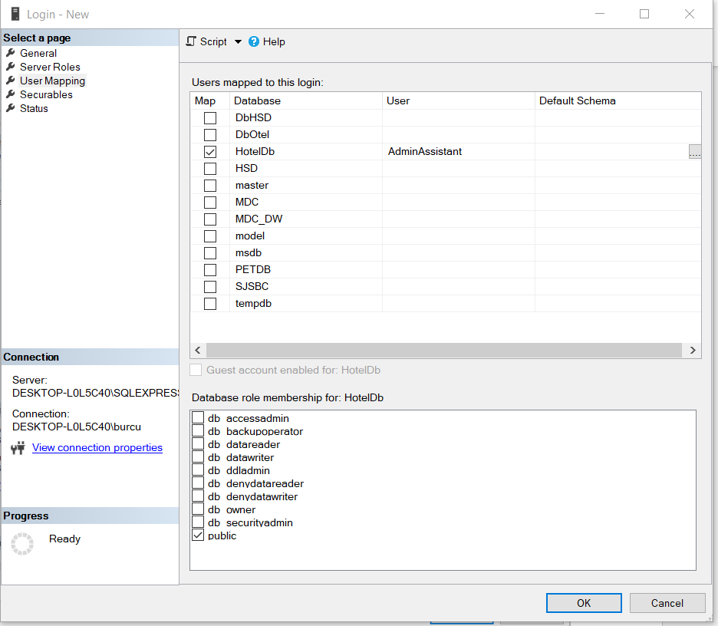

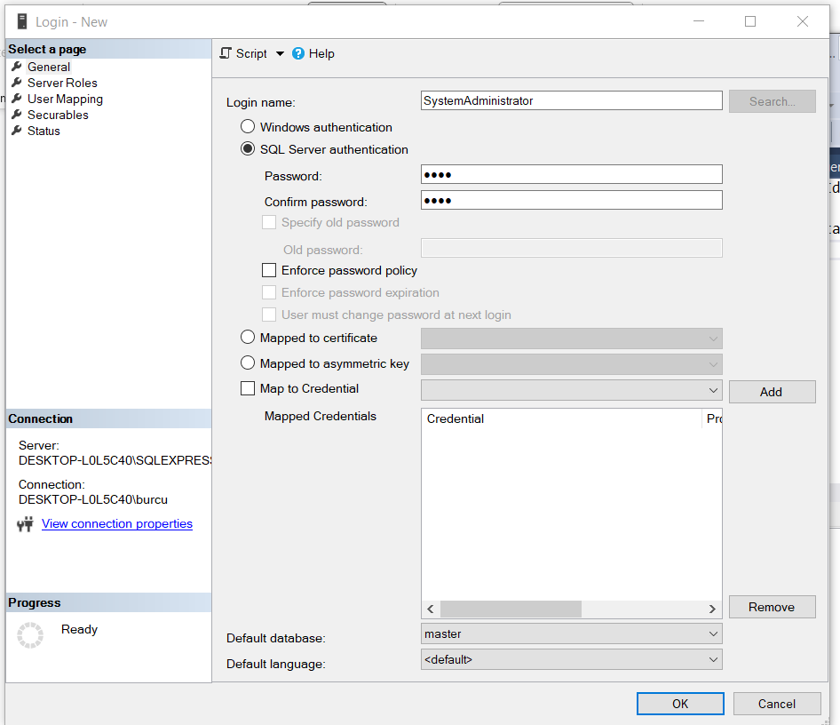

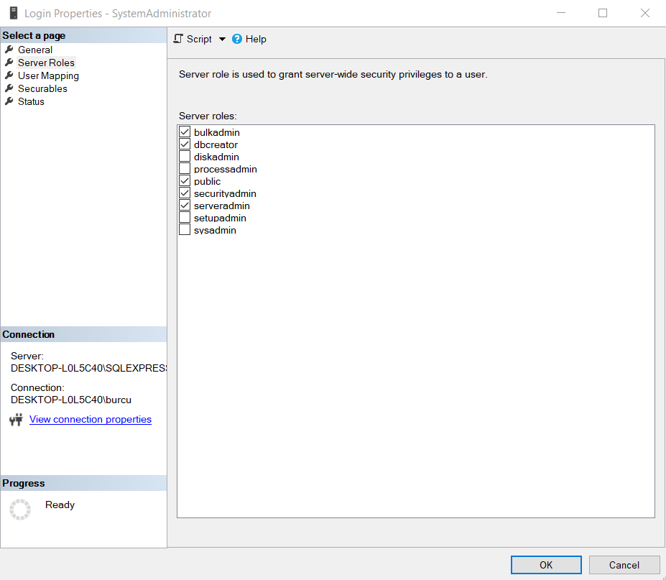

-System Administrator’s Server Roles-

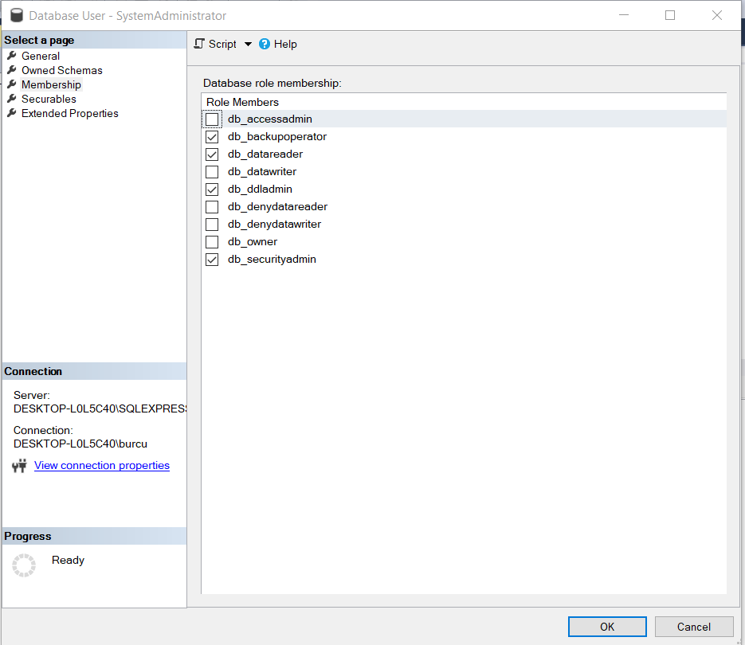

-System Administrator’s Permissions for database-

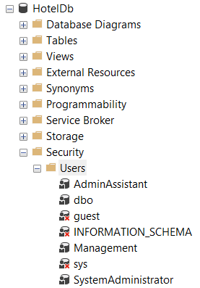

You can see three user names created by me for the HoteldDb database: AdminAssistant, Management and SystemAdministrator

I tailored permissions to "Management" and "AdminAssistant" users for the operations they can perform on the tables in Hoteldb. You can see the details in the following screenshots. You can find the “Database Rights Granted” table, which contains detailed information on the subject, on page 9 and page 10.

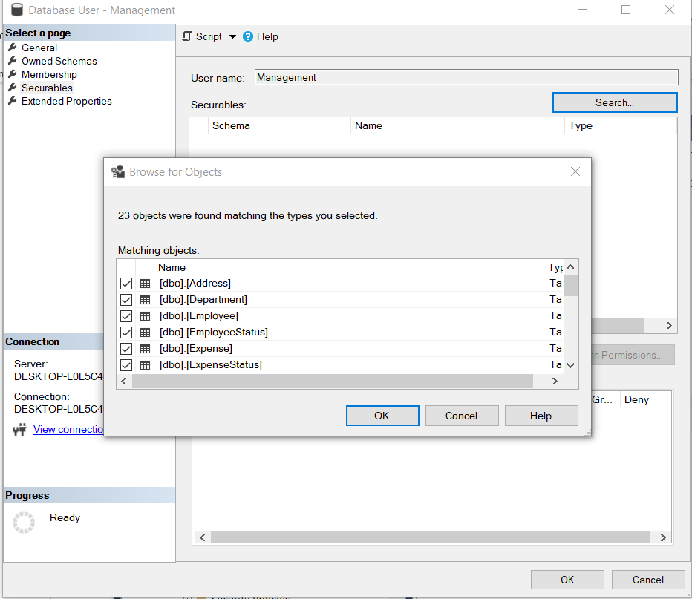

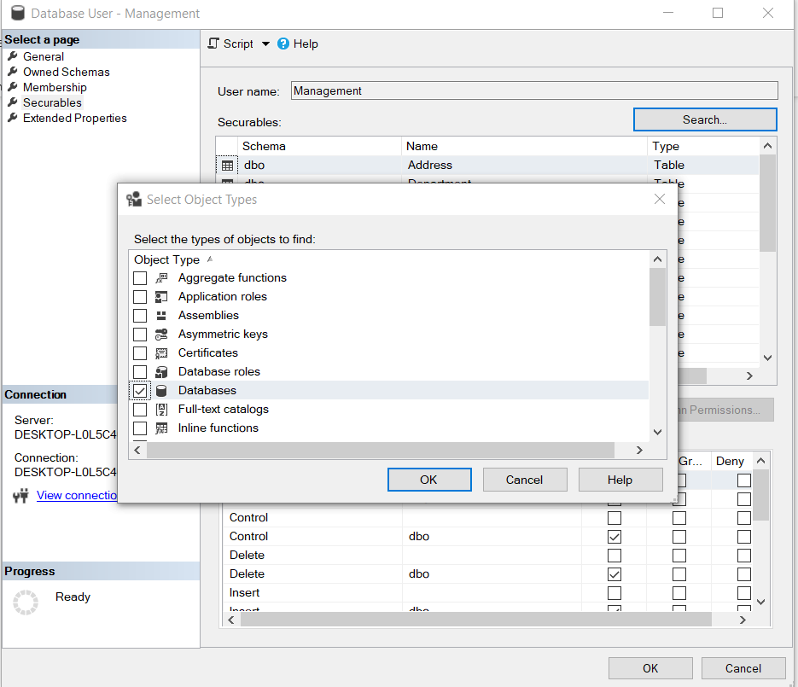

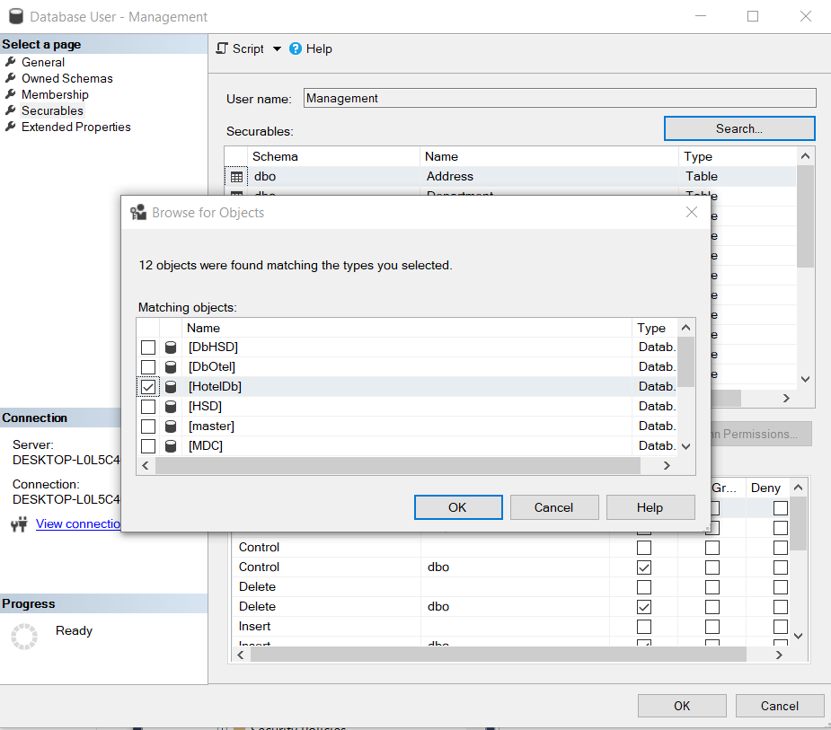

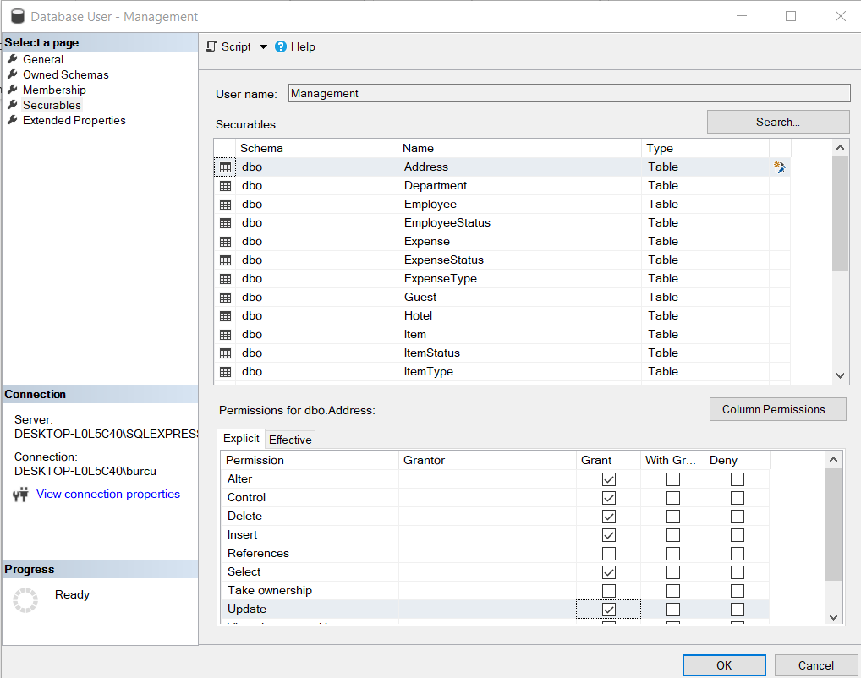

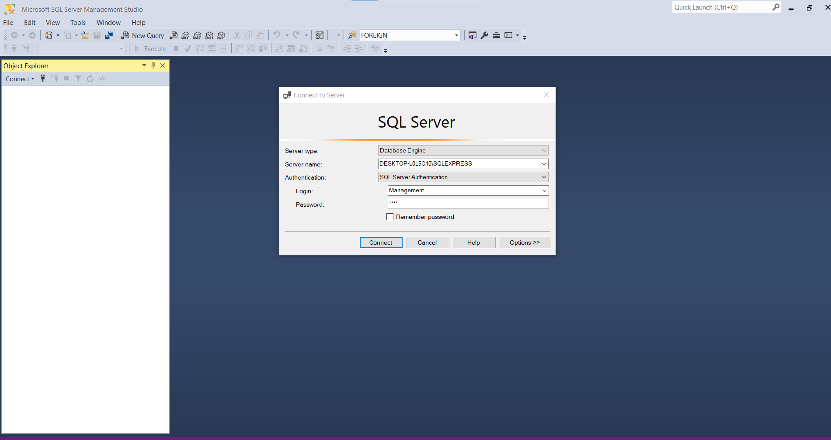

After completing all the work, I log in to the database with the new login information and check whether the permissions are working successfully.

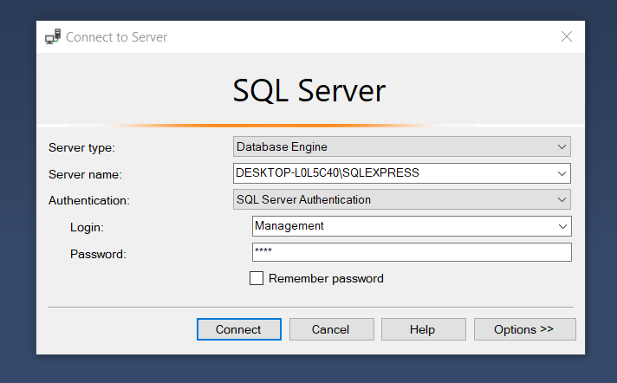

As you can see “SQL Server 15.0.2000- Management”, I could login with one of the login names.

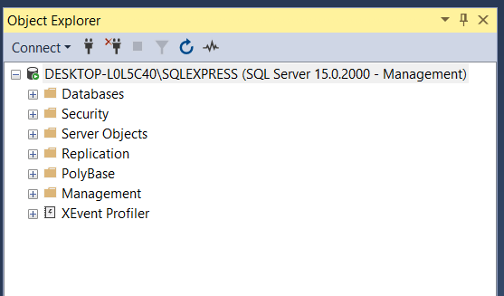

**PERFORMANCE OPTIMIZATION**

For performance optimization, I added index for “FirstName” and “LastName” columns to the Guest table because the data of this table will increase and if the hotel management wants to search using FirstName and LastName string value type fields, this may affect the performance of the table and database. Because the database will search all table row by row these string values. However, if I add an index value, it will find string values ​​more easily without any performance loss.

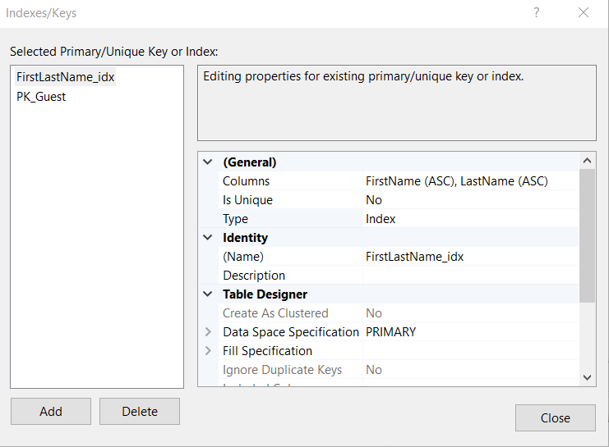

**ENTITY RELATIONSHIP EXAMPLE**

To show how to use foreign keys and give more detail about database and tables, I created a query. As a result of this query, in which I connect 10 tables, we can get information about the relevant customer's name and surname, the name of the product he purchased, the type of room she stayed in, the quantity of the product, payment status. You can see in the below:

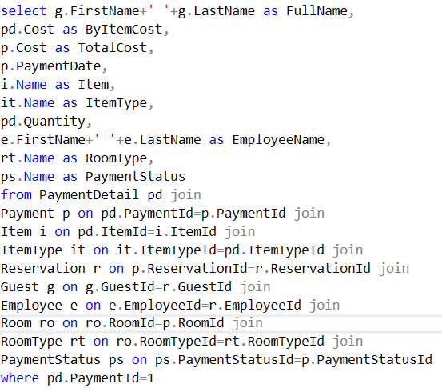

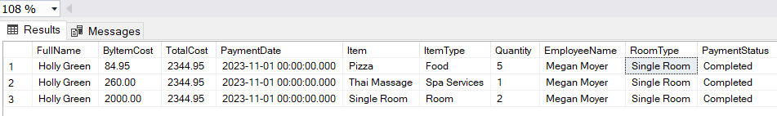

# References

David M. Kroenke, D. J. (2020). *Database concepts/David M. Kroenke, David J. Auer, Western Washington University, Scott L. Vandenberg, Siena College, Robert C. Yoder, Siena College.* (Ninth Edition ed.). New York: Pearson.